**Group Project Rubric**

|  |  |  |  |  |  |  |
| --- | --- | --- | --- | --- | --- | --- |
| **ISYS 624** | **Section Number: 602** | | | **Group Number: 4** | | |
| **Project Title:** | **Easy N Fresh Integrated Online Delivery System** | | | | | |
| **Student Photo** | **C:\Users\kirth\Downloads\Agarwal_Vivek_Compressed.jpg** | **C:\Users\kirth\Desktop\unnamed.jpg** | **C:\Users\kirth\Downloads\DSC_9090~2.jpg** | | **C:\Users\kirth\Downloads\Saddam (1).jpg** | **C:\Users\kirth\Desktop\Desktop\Vasudevan_Kirthan 1.jpg** |
| **Last Name:** | **Aggarwal** | **Garg** | **Geetha Surendran** | | **Hussain** | **Vasudevan** |
| **First Name:** | **Vivek** | **Sumit** | **Sree Lakshmi** | | **Saddam** | **Kirthan** |

|  |  |  |  |
| --- | --- | --- | --- |
|  | **Max Points** | **Given Points** | **Comments** |
| **Conformance to Requirements** | **30** |  |  |
| **Scope** | **20** |  |  |
| **Clarity of Organization** | **20** |  |  |
| **Quality of Written Presentation** | **20** |  |  |
| **Quality of Live Presentation** | **10** |  |  |
| **TOTAL** | **100** |  |  |

**TABLE OF CONTENTS**

1. Problems & Limitations of Existing System……………………………...........................3

2. Objective………………………………………………………………………………….3

3. Class Diagram

3.1 Class Diagram with Associations………………………………………………...4

3.2 Inheritance Class Diagram………………………………………………………..5

3.3 Aggregation Class Diagram………………………………………………………6

3.4 Data Dictionary of ENF…………………………………………………………..7

4. Database Diagram………………………………………………………………………..14

5. UML Diagrams…………………………………………………………………………..15

5.1 Context Diagrams for Current System…………………………………………...15

5.2 Context Diagram for ENF………………………………………………………..16

5.3 Activity Diagrams……………………………………………………..................17

5.4 Use case Diagrams……………………………………………………………….25

5.5 Sequence Diagrams………………………………………………………………33

6. Functionalities……………………………………………………………………………41

7. Screenshots………………………………………………………………………………42

8. References………………………………………………………………………………..49

**1 Problems & Limitations of Existing System**

In today’s scenario when you are just a click away from buying anything you want, the consumer perishable segment is still left wanting. Currently, there are no provisions for the customer to buy basic perishable goods such as groceries, dairy products online.

As per the current system, customers end up spending a huge chunk of their valuable time in going to places like Walmart, HEB and buying groceries. There is no integrated system that connects various retailers and coordinates the delivery system.

**2 Objective**

To simplify and ease out customer’s perishable goods shopping experience by providing an integrated online delivery system, bringing together all major vendors on one common platform. Our system integrates online delivery system for various retailers.

1. To make customer shopping for perishable goods easier and more convenient.
2. To design a user friendly eCommerce website which integrates multiple retailer products at one place.
3. Provide easier shopping experience with our own wallet and loyalty management program.
4. Platform where a customer can compare product availabilities and prices with a advanced analytics system.

**3 Class Diagram**

**3.1 Class Diagram with Association**

**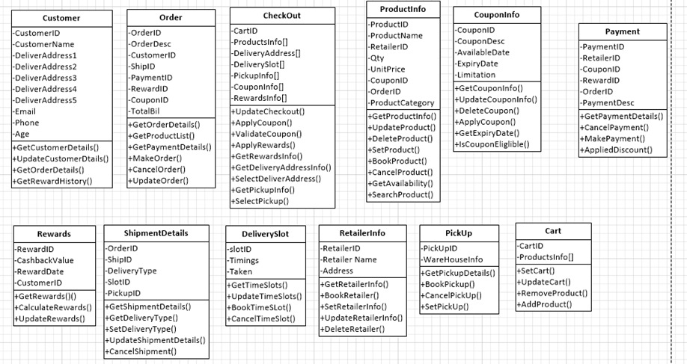**

**Fig. 1 Class Diagram for ENF system**

Class diagram describes structure of a system by showing the system's classes, their attributes, operations (or methods), and the relationships among objects. Here our system has classes for customer, order, checkout, information on product info, coupon information , payment information , shipment of the order and pickup options and provides information on various attributes and methods that handle this information.

**3.2 Inheritance Class Diagram**

**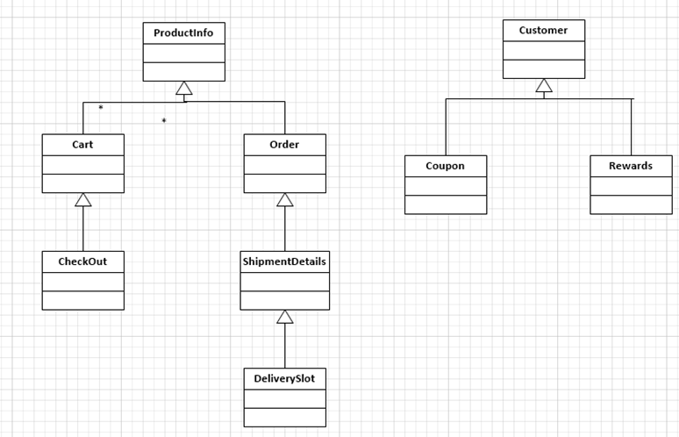**

**Fig. 2 Inheritance Class Diagram for ENF system**

The inheritance diagram shows levels of classes with inheritance from the parent. Checkout is done on basis of info from cart and cart consists of product info. Delivery slot has shipment details which contains info from the order which in turn is has product info. The coupon and Rewards class contains details of customer class.

**3.3 Aggregation Class Diagram**

**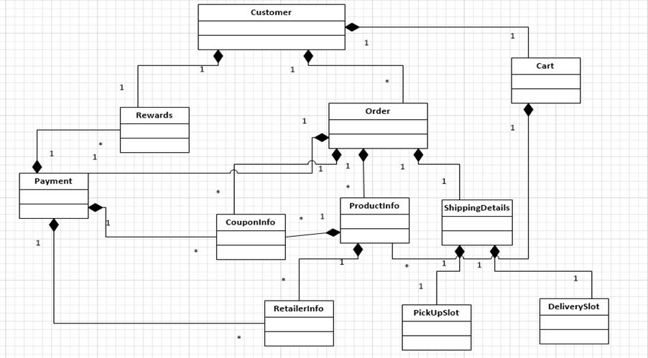**

**Fig. 2 Aggregation Class Diagram for ENF system**

We have various classes with aggregated objects inside it. For example, order class will be having various objects of products as an order will have multiple aggregated structures. More detailed description can be found in the data dictionaries attached.

**3.4 Data Dictionary of Easy N Fresh Integrated Online Delivery System**

**Classes:**

|  |
| --- |
| **Class 1: Customer** |
| Description: Customer class can record / update personal details of customer and can view order related information. |
| Attribute 1: Customer ID  Description: Customer ID is the primary key |
| Attribute 2: Customer Name  Description: Stores name of customer |
| Attribute 3: Delivery Address1  Description: Stores delivery address |
| Attribute 4: Email  Description: Stores email of customer |
|  |
| Operation 1: GetCustomerDetails()  Description: Function fetches customer details |
| Operation 2: UpdateCustomerDetails()  Description: Function updates customer details |
| Operation 3GetOrderDetails()  Description: Function fetches order details |
| Operation 1: GetRewardsHistory()  Description: Function fetches rewards history. |

|  |
| --- |
| **Class 2: Order** |
| Description: Order class has order details, shipment details of customer and can view reward related information. |
| Attribute 1: OrderDesc  Description: Has information regarding the order |
| Attribute 2: RewardID  Description: Stores the ID of the reward seeking customer |
| Attribute 3: TotalBill  Description: Stores billing information |
|  |
| Operation 1: GetPaymentDetails()  Description: Function fetches payment details |
| Operation 2: MakeOrder()  Description: Function creates an order details |

|  |
| --- |
| **Class 3: CheckOut** |
| Description: Class helps in choosing delivery slot and pickup information |
| Attribute 1: ProductInfo  Description: Stores information of products |
| Attribute 2: DeliverySlot  Description: Allows customer to choose from various delivery slot |
| Attribute 3: CouponInfo  Description: Stores coupon information |
|  |
| Operation 1: ApplyRewards()  Description: Function applies the right rewards product wise |
| Operation 2: GetPickupInfo()  Description: Functions fetches pickup info for the order |

|  |
| --- |
| **Class 4: Shipment Details** |
| Description: Shipment class stores shipment details. |
| Attribute 1: DeliveryType  Description: Allows user to choose between pickup and delivery type. |
| Attribute 2: SlotID  Description: Stores delivery slot information |
|  |
| Operation 1: GetShipmentDetails()  Description: Functions fetches Shipment details |
| Operation 2: UpdateShipmentDetails()  Description: Functions updates shipment details |
| **Class 5: Product Info** |
| Description: Product Info class can record / update product details of order and can view product related information. |
| Attribute 1: ProductName  Description: Stores product name |
| Attribute 2: Qty  Description: Stores product quantity |
| Attribute 3: UnitPrice  Description: Stores unit price |
| Operation 1: SetProduct()  Description: Adds new product to list |
| Operation 2: CancelProduct()  Description: Delete Product from list |
| **Class 6: Coupon Info** |
| Description: Coupon class stores coupon related information |
| Attribute 1: CouponDesc  Description: Stores coupon informatio |
| Attribute 2: Limitation  Description: Stores terms and conditions |
| Operation 1: ApplyCoupon()  Description: Function applies coupon to product |
| Operation 2: IsCouponEligible()  Description: Checks whether coupon meet terms and conditions |
| **Class 7: Rewards** |
| Description: Class has cashback and rewards information |
| Attribute 1: CashbackValue  Description: Stores information of amount of cashback |
| Attribute 2: Reward date  Description: Shows date when reward is applied |
| **Class 8: DeliverySlot** |
| Description: Class helps in choosing delivery slot and pickup information |
| Attribute 1: Timings  Description: Choose delivery timings |
| Attribute 2: Taken  Description: Checks if the products are received |
| Operation 1: bookTimeSlot()  Description: Function helps get time slot information |
| Operation 2: UpdateTimeSlot()  Description: Functions updates time slot |

|  |
| --- |
| **Class 9: Payment** |
| Description:  Handles and saves payment order details. |
| Attribute 1: paymentID  Description:  Unique primary key value of Payment table. |
| Attribute 2: retailerID  Description:  Value maps with retailerID of RetailerInfo table. |
| Attribute 3: rewardID  Description:  Value maps with rewardID of Rewards table. |
| Attribute 4: orderID  Description:  Value maps with orderID of Order table. |
| Attribute 5: paymentDesc  Description:  Saves payment details |
| Operation 1: getPaymentDetails()  Description:  To retrieve payment details from ENF DB. |
| Operation 2: cancelPayment()  Description:  To save details of payments which are cancelled. |
| Operation 3: makePayment()  Description:  Saves payment details into DB. |
| **Class 10 : Cart** |
| Description:  Saves and handles cart details. |
| Attribute 1: cartID  Description:  Unique primary key value of Cart table |
| Attribute 2: productsInfo[]  Description:  Value maps with productsInfo[] of ProductInfo table. |
| Operation 1: getPaymentDetails()  Description:  To retrieve payment details from ENF DB. |
| Operation 2: setCart()  Description:  To save details of carts into DB. |
| Operation 3: updateCart()  Description:  Saves updated cart details into DB. |
| Operation 4: addProduct()  Description:  To add a product into cart and thus save it to DB. |
| **Class 11 : PickUp** |
| Description:  Saves and handles pickup order details. |
| Attribute 1: pickupID  Description:  Unique primary key value of pickUp table |
| Attribute 2: warehouseInfo  Description:  Value maps with productsInfo[] of ProductInfo table. |
| Operation 1: getPaymentDetails()  Description:  To retrieve payment details from ENF DB. |
| Operation 2: setCart()  Description:  To save details of carts into DB. |
| Operation 3: updateCart()  Description:  Saves updated cart details into DB. |
| Operation 4: addProduct()  Description:  To add a product into cart and thus save it to DB. |

**Associations:**

|  |
| --- |
| Association 1: Customer table and Order Table one-to-many  Description:  CustomerID of Customer table with customerID of Order table. |
| Association 2: Order and Checkout one-to-one  Description:  One order will be having a single Checkout entry |
| Association 3: Cart and Checkout one-to-one  Description:  One cart will be having a single Checkout entry |
| Association 4: Customer and CouponInfo one-to-many  Description:  One customer will be having multiple coupons available. |
| Association 5: Customer and Rewards one-to-many  Description:  One customer will be having multiple rewards available. |
| Association 6: Order and Payment one-to-one  Description:  One customer will be having multiple rewards available. |
| Association 7: Order and Pick up one-to-one  Description:  One customer will be having one delivery option. |

**Table 1. Data Dictionaries**

**4 Database Diagram**

**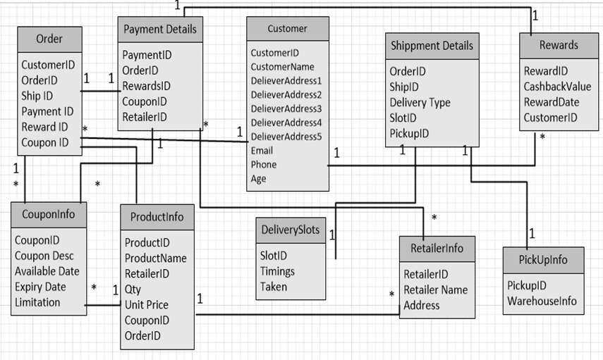**

**Fig. 4 Database Diagram for ENF system**

**5 UML Diagrams**

**5.1 Context Diagram for current system**

**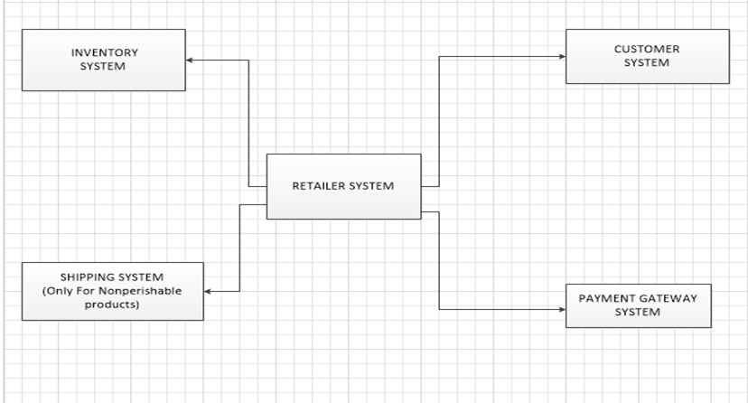**

**Fig. 5 Context Diagram of existing system**

The current online retailer delivery system does not provide delivery for perishable goods. At the same time, a customer cannot see the same product available with various retailers. The current system has an inventory, a customer system which will be the eCommerce website, a payment gateway and a shipping system**.** The above system exists only for non-perishable goods.

**5.2 Context Diagram for Easy N Fresh**

**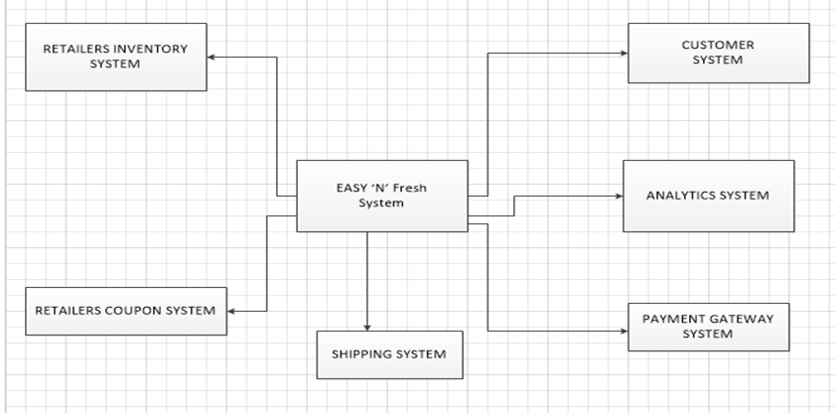**

**Fig. 6 Context Diagram of ENF system**

Easy N Fresh provides an integrated online delivery system where customer can avail a doorstep delivery of perishable goods. Customer get to choose products from different retailers, see the price, compare it and choose for his favorite option. The product details and categories are fetched from a Retailer Inventory System and stored in Easy N Fresh database. The customer system is the eCommerce user interface end with which the customer interacts with the Easy N Fresh system. The analytics system handles the data analytics part which chooses the 3 bestselling products to be displayed on the product display grid.

**5.3 Activity Diagrams**

**5.3.1 Activity diagram of ENF system for Customer**

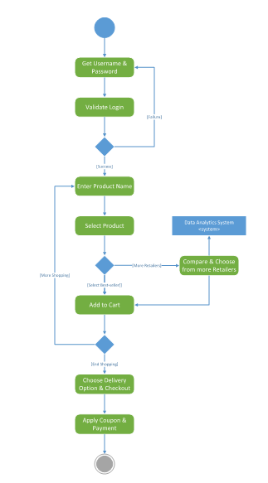

**Fig. 7 Activity Diagram 1 of ENF system**

**Description:**

On start, Username and password is requested. On entering the details validation is done. If failed the login page is prompted again, else the main page is opened. Next the user can search for the product he wishes to buy. Select desired product from the available list. The analytical system suggests the same product from different retailers. On choosing the desired retailer, the product can be added to cart at the best price. Now the customer has the option to add another product, which can happen till all the products are added to cart or end the purchase by choosing the desired delivery mode and address before pursuing for checking out. Next, coupons are added and payment is processed which ends the activity.

**5.3.2 Activity Diagram of ENF system for Admin**

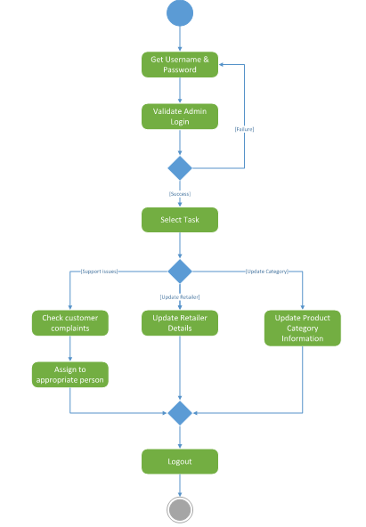

**Fig. 7 Activity Diagram 2 of ENF system**

**Description:**

On start, an admin Username and password is requested. On entering the details validation is done. If failed the login page is prompted again, else the main page. One of the 3 tasks can be chosen to be done. If support issues are reported, customer complaints can be checked and then can be assigned to the right person to be addressed. Else if a new retailer is to be added to the system, admin can update retailer details. Another alternative option the admin would like to go ahead is update product category information in our local system. Once the required operation is completed, the admin can logout.

**5.3.3 Activity Diagram of ENF system for Store Manager**

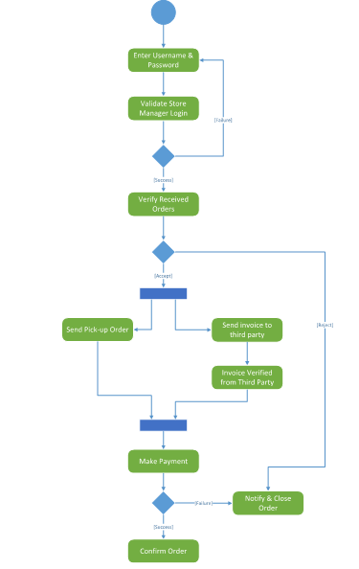

**Fig. 8 Activity Diagram 3 of ENF system**

**Description:**

The orders placed by clients need to be verified based on inventory. If the order is accepted 2 operations take place simultaneously, first the order list is sent for pick up from the respective stores and then the invoice amount is sent to payment gateway. On successful payment, the order conformation is sent to customer and the payment is closed. If the order placed is not verified or payment fails, the failed order information is sent to customer and the activity is ended.

**5.3.4 Activity Diagram of ENF system for IT Sync Service**

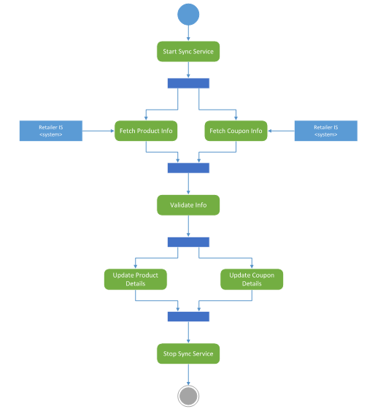

**Fig. 9 Activity Diagram 4 of ENF system**

**Description:**

On starting the sync service, in order to keep the local database up-to-date the service fetches product information from the retailer IS system apart from fetching coupons from the same retailer system. This information is validated and once successful the new product and coupon details are updated in Easy n fresh locally. On updating the sync service is stopped.

**5.4 Use Case Diagrams**

**5.4.1 Use case diagram of ENF system for Customer**

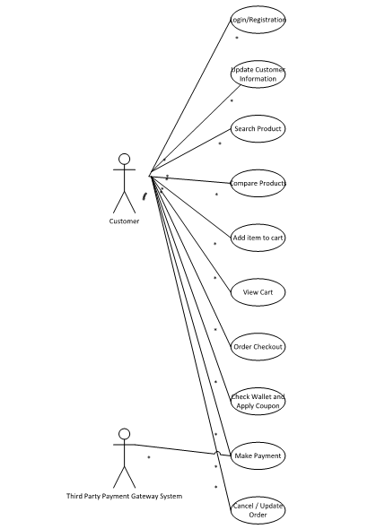

**Fig. 10 Use Case Diagram 1 of ENF system**

**Description:**

|  |  |
| --- | --- |
| **ENF : Customer Use case** | |
| Actors | Customers (End users ) |
| Description | A customer on login can search for products and add them to shopping cart. He can also check and avail the coupons and discounts at any time according to his convenience. |
| Data | Customer details, Product details, Shopping cart details and Payment. |
| Stimulus | User commands issued by customer |
| Response | Search product found; Product added to cart; Successful payment resulting in successful order placement. |
| Comments | The customer will be able to view and choose products from different retailers. |

**Table 2. Use Case Description 1**

**5.4.2 Use case diagram of ENF system for Admin**

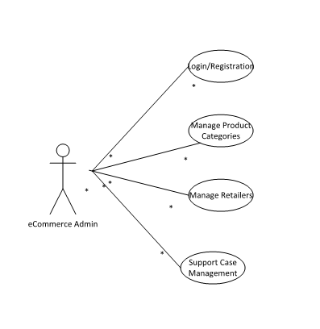

**Fig. 11 Use Case Diagram 2 of ENF system**

**Description:**

|  |  |
| --- | --- |
| **ENF : Customer Use case** | |
| Actors | eCommerce Admin (End users ) and ENF system |
| Description | Admin has all the right to make changes to any of the subsystems in the ENF system. He can add/update/remove product details , product categories , retailer details , payment options etc. |
| Data | Customer details, Product details, Retailer details, Payment. |
| Stimulus | User commands issued by eCommerce admin. |
| Response | Make changes to subsystem as required |
| Comments | The admin has the right to make any major change in the ENF system. |

**Table 3. Use Case Description 2**

**5.4.3 Use case diagram of ENF system for Warehouse Manager**

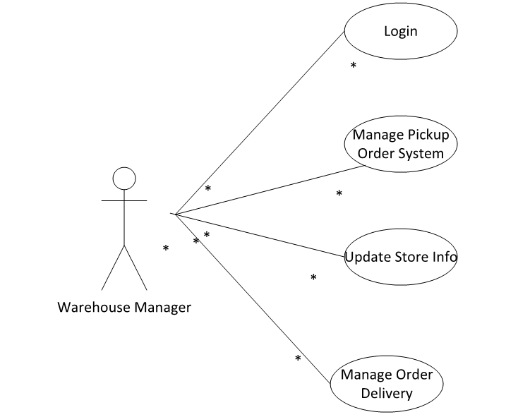

**Fig. 12 Use Case Diagram 3 of ENF system**

**Description:**

|  |  |
| --- | --- |
| **ENF : Warehouse Manager Use case** | |
| Actors | Store Manager and ENF system |
| Description | A store manager manages the pickup delivery option from a warehouse. He manages the product delivery system for pickup orders. |
| Data | Customer details, Order details. |
| Stimulus | User commands issued by store manager |
| Response | Confirm a pickup order; Update pickup order. |
| Comments | The store manager has access only to the pickup order details from his warehouse. |

**Table 4. Use Case Description 3**

**5.4.4 Use case diagram of ENF system for IT Sync System**

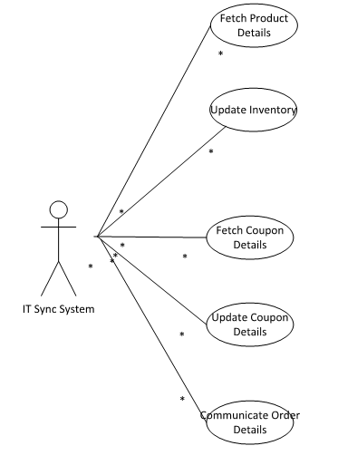

**Fig. 13 Use Case Diagram 4 of ENF system**

**Description:**

|  |  |
| --- | --- |
| **ENF : IT sync system Use case** | |
| Actors | IT sync system and ENF system |
| Description | This is the batch process system that runs periodically to fetch product details from respective retailer systems and store them in ENF database. |
| Data | Product details , Retailer details |
| Stimulus | Automated periodic batch process. |
| Response | Update product details in ENF system; |
| Comments | The IT Sync system runs periodically and populates data in ENF database, which will be accessed by the data analytics system to find the best seller and by ENF subsystem to display product details. |

**Table 5. Use Case Description 4**

**5.5 Sequence Diagrams**

**5.5.1 Sequence diagram of ENF system for Customer Product Search**

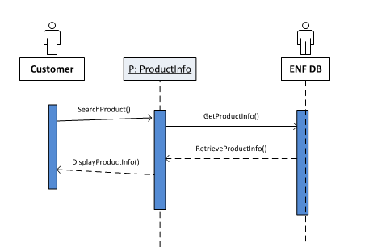

**Fig. 14 Sequence Diagram 1 of ENF system**

**Description**

The customer searches for the desired product from the enlisted product categories.The customer performs the following functions in this figure:

1. SearchProduct(): searches for the desired product from the products category
2. GetProductInfo(): gets product information for the selected product
3. RetrieveProductInfo(): retrieves product information for the selected product
4. DisplayProductInfo(): displays product information for the selected product

**5.5.2 Sequence diagram of ENF system to choose the Retailer**

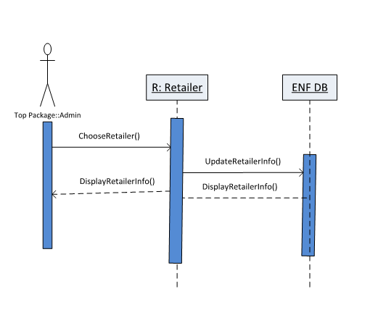

**Fig. 15 Sequence Diagram 2 of ENF system**

**Description:**

Ecommerce Admin performs the following functions:

1. ChooseRetailer(): chooses from the available retailers
2. UpdateRetailerInfo(): updates retailer information
3. DisplayRetailerInfo(): displays retailer information

**5.5.3 Sequence diagram of ENF system for IT sync system**

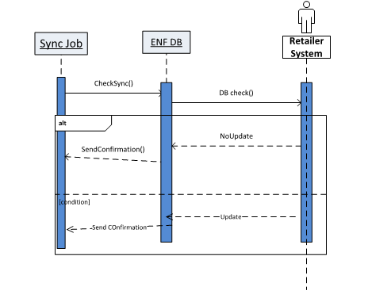

**Fig. 16 Sequence Diagram 3 of ENF system**

**Description:**

The sync job system is responsible for ensuring that the product inventory is updated and in sync with the vendor inventory system.

1. CheckSync() automates the function to run the IT sync batch process.
2. DBCheck() has to sends request to Retailer DB to get data and populate it in ENF DB.
3. If there is no update from a particular Retailer DB to our ENF DB then a NoUpdate will be sent.
4. Then sendConfirmation() confirms the NoUpdate.
5. If there is any update then sendConfirmation() confirms the update and save the updated data in ENF DB.

**5.5.4 Sequence diagram of ENF system for Order Update by Warehouse Manager**

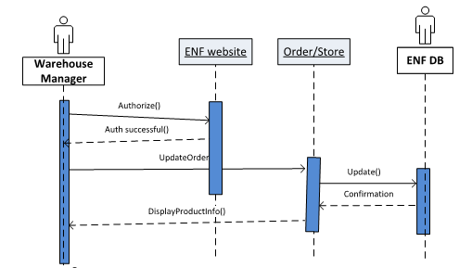

**Fig. 17 Sequence Diagram 4 of ENF system**

**Description:**

1. The warehouse manager interacts with the ENF website, Order/store and ENF DB.
2. Authorizes and updates, displays the order details.
3. Warehouse Manager coordinates with different stores to maintain inventory and retrieves the store details for existing stores.
4. Manages and updates the store information. Displays a success message if update successful.

**5.5.5 Sequence diagram of ENF system to find product category**

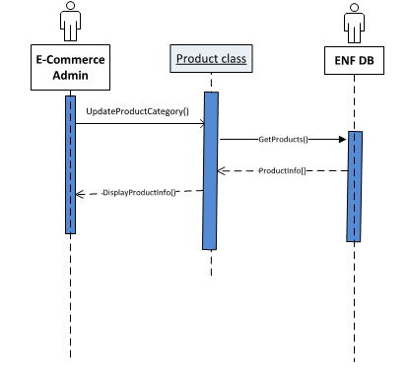

**Fig. 18 Sequence Diagram 5 of ENF system**

**Description:**

Ecommerce Admin manages the retailers and ensures that the order is fulfilled by the retailer chosen by the customer. For ex: if the customer choose HEB instead of Walmart it is the duty of Ecommerce Admin to ensure the order is fulfilled by HEB.

1. UpdateProductCategory() will send a request to DB to update details about a particular product.
2. GetProduct() returns product details to be updated.
3. ProductInfo() retrieves the updated product info from ENF DB.
4. DisplayProductInfo() sends the updates product details to the User Interface.

**5.5.6 Sequence diagram of ENF system to view cart**

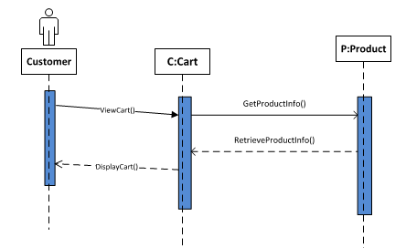

**Fig. 19 Sequence Diagram 6 of ENF system**

**Description:**

Customer can view his cart using the View Cart option.

1. viewCart() will send a request to retrieve the order and product details added by the customer to the cart.
2. getProductInfo() requests product details from Product class.
3. RetrieveProductInfo() will retrieve product details from Product class and send it back to Cart class.
4. DisplayCart() gets the details and display it in the User Interface.

**5.5.7 Sequence diagram of ENF system to update store details**

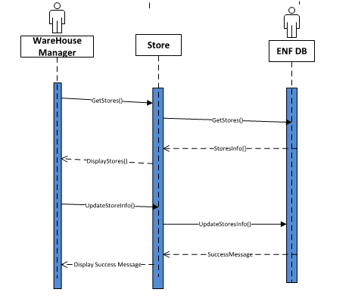

**Fig. 20 Sequence Diagram 7 of ENF system**

**Description:**

Warehouse manager can update store details such as store address, inventory details.

1. GetStores() retrieves store details from ENF DB.
2. StoresInfo() retrieves store details and display details using DisplayStores().
3. UpdateStoreInfo() updates the store information and save it in DB.
4. If the update is successful then a success message is sent to the user end.

**5.5.8 Sequence diagram of ENF system for checkout**

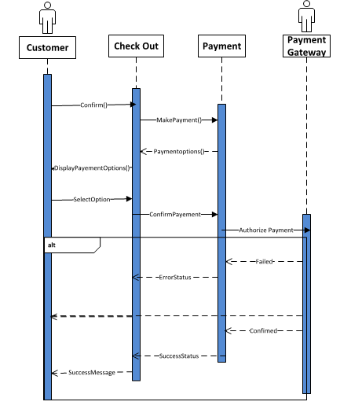

**Fig. 21 Sequence Diagram 8 of ENF system**

**Description:**

1. On customer confirming his order, confirm() , he will be taken to the order checkout page.
2. After checkout, makePayment() will direct the customer to the payment page where he confirms payment method and pay for the order.
3. AuthorizePayment() will confirm with the third party payment gateway and places the payment.
4. If payment is not successful, an error message is displayed. Similarly, if payment is successful, confirmation message is displayed.

**6 Functionalities:**

**Online Delivery System:** Enables the customer to select perishable products they want from distinct vendors and get them delivered at their doorstep. A customer can search for different products available with various retailers and choose the products he wishes to buy. **Easy N Fresh** will integrate and place orders with various retailers. The customer does not need to go to different retailer websites and make payment separately. Instead he can make one single payment for his total order, which **Easy N Fresh** will process together and handle through a third party gateway system.

**For Instance:** A customer can order dairy products from Walmart and vegetables from HEB and get them delivered.

**Benefit:** It enables the customer to build a customized order without the hassles of going to separate vendors, saving both time and cost.

**Select Product Category:** Enables the customer to search for desired products based on product categories such as groceries, vegetables, fruits, dairy and eggs, meat & sea food, canned food.

**Payment and Checkout:** Integrated payment system which helps the customer to pay for their order online.

**Wallet:** In addition to the common modes of payment i.e. debit and credit card. The customer can choose to pay using a secure digital wallet where you can store money and use it to do online shopping.

**7 Screenshots**

The process flow is as follows:

1. **Customer login / Registration**

The customer log in through **Easy N Fresh** system.

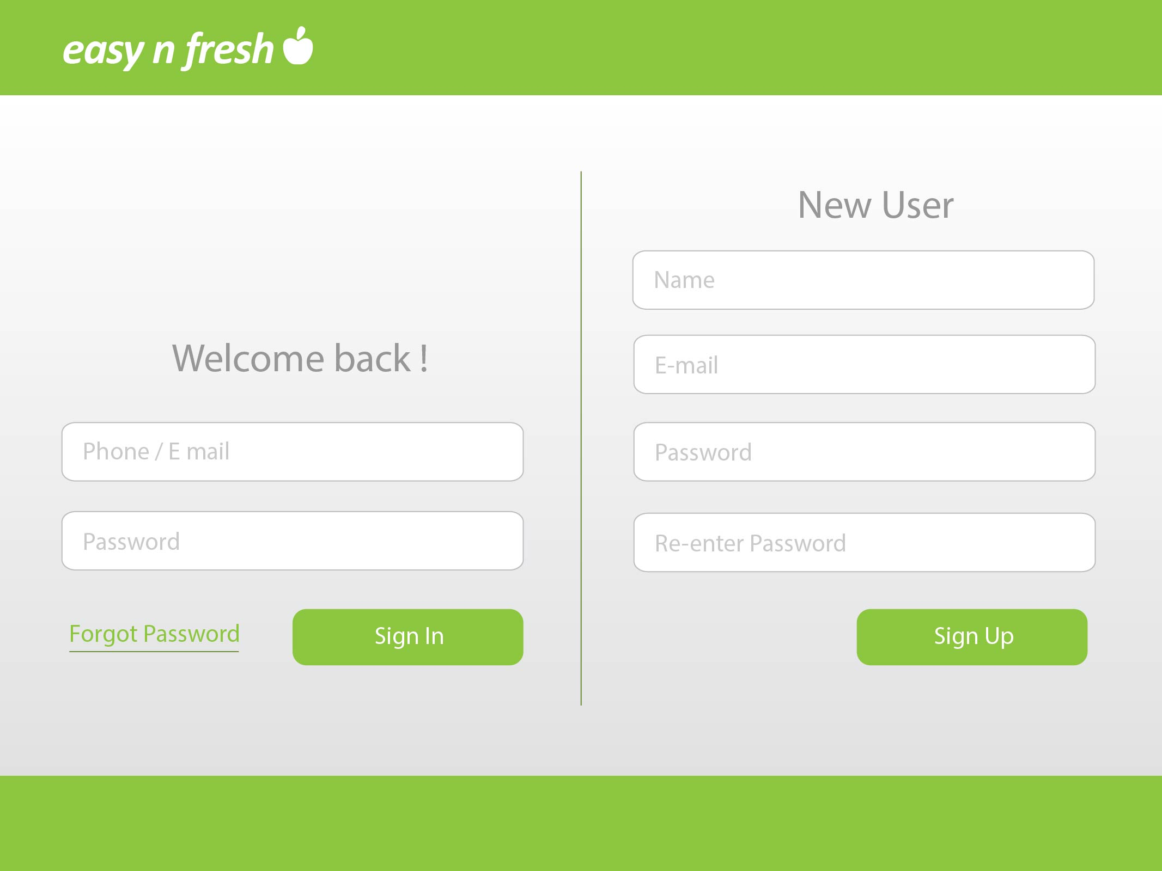

**Fig. 22 Screenshot 1 of ENF system**

1. **Product Search.**

In the **Easy N Fresh system** the user can browse and search for products.

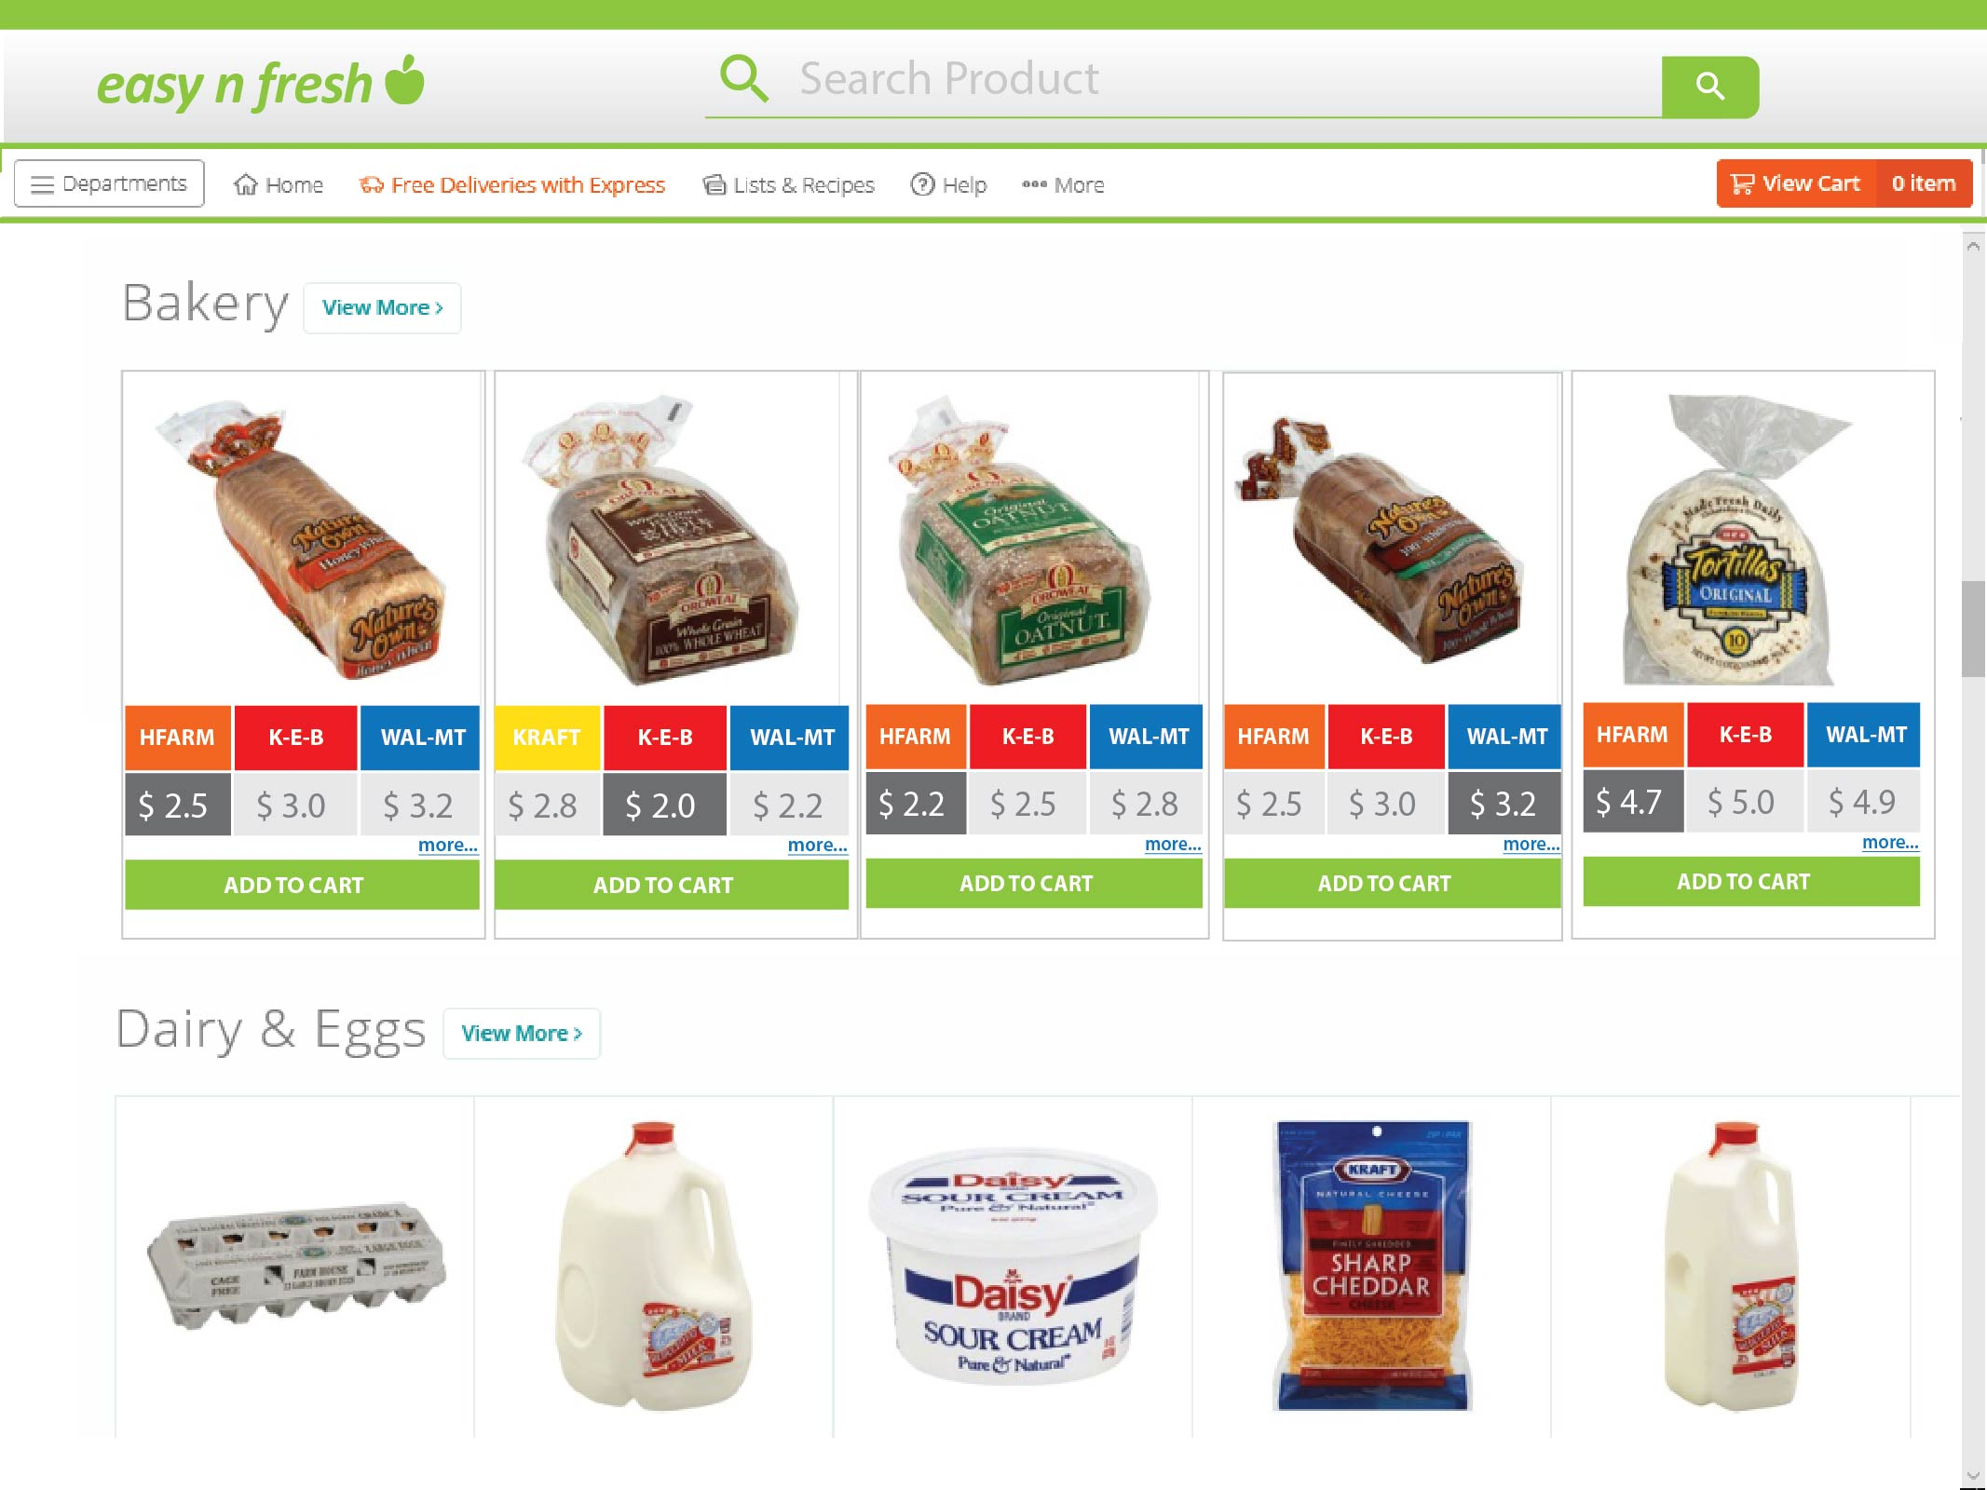

**Fig. 23 Screenshot 2 of ENF system**

1. **Category Search**

The customer can do a category search to choose the product.

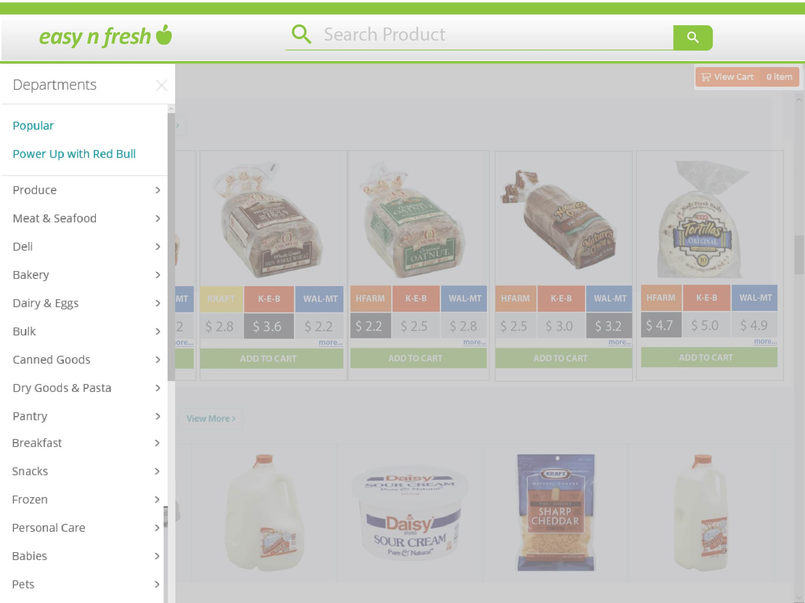

**Fig. 24 Screenshot 3 of ENF system**

1. **Order History**

Customer can see his order history and details in this page

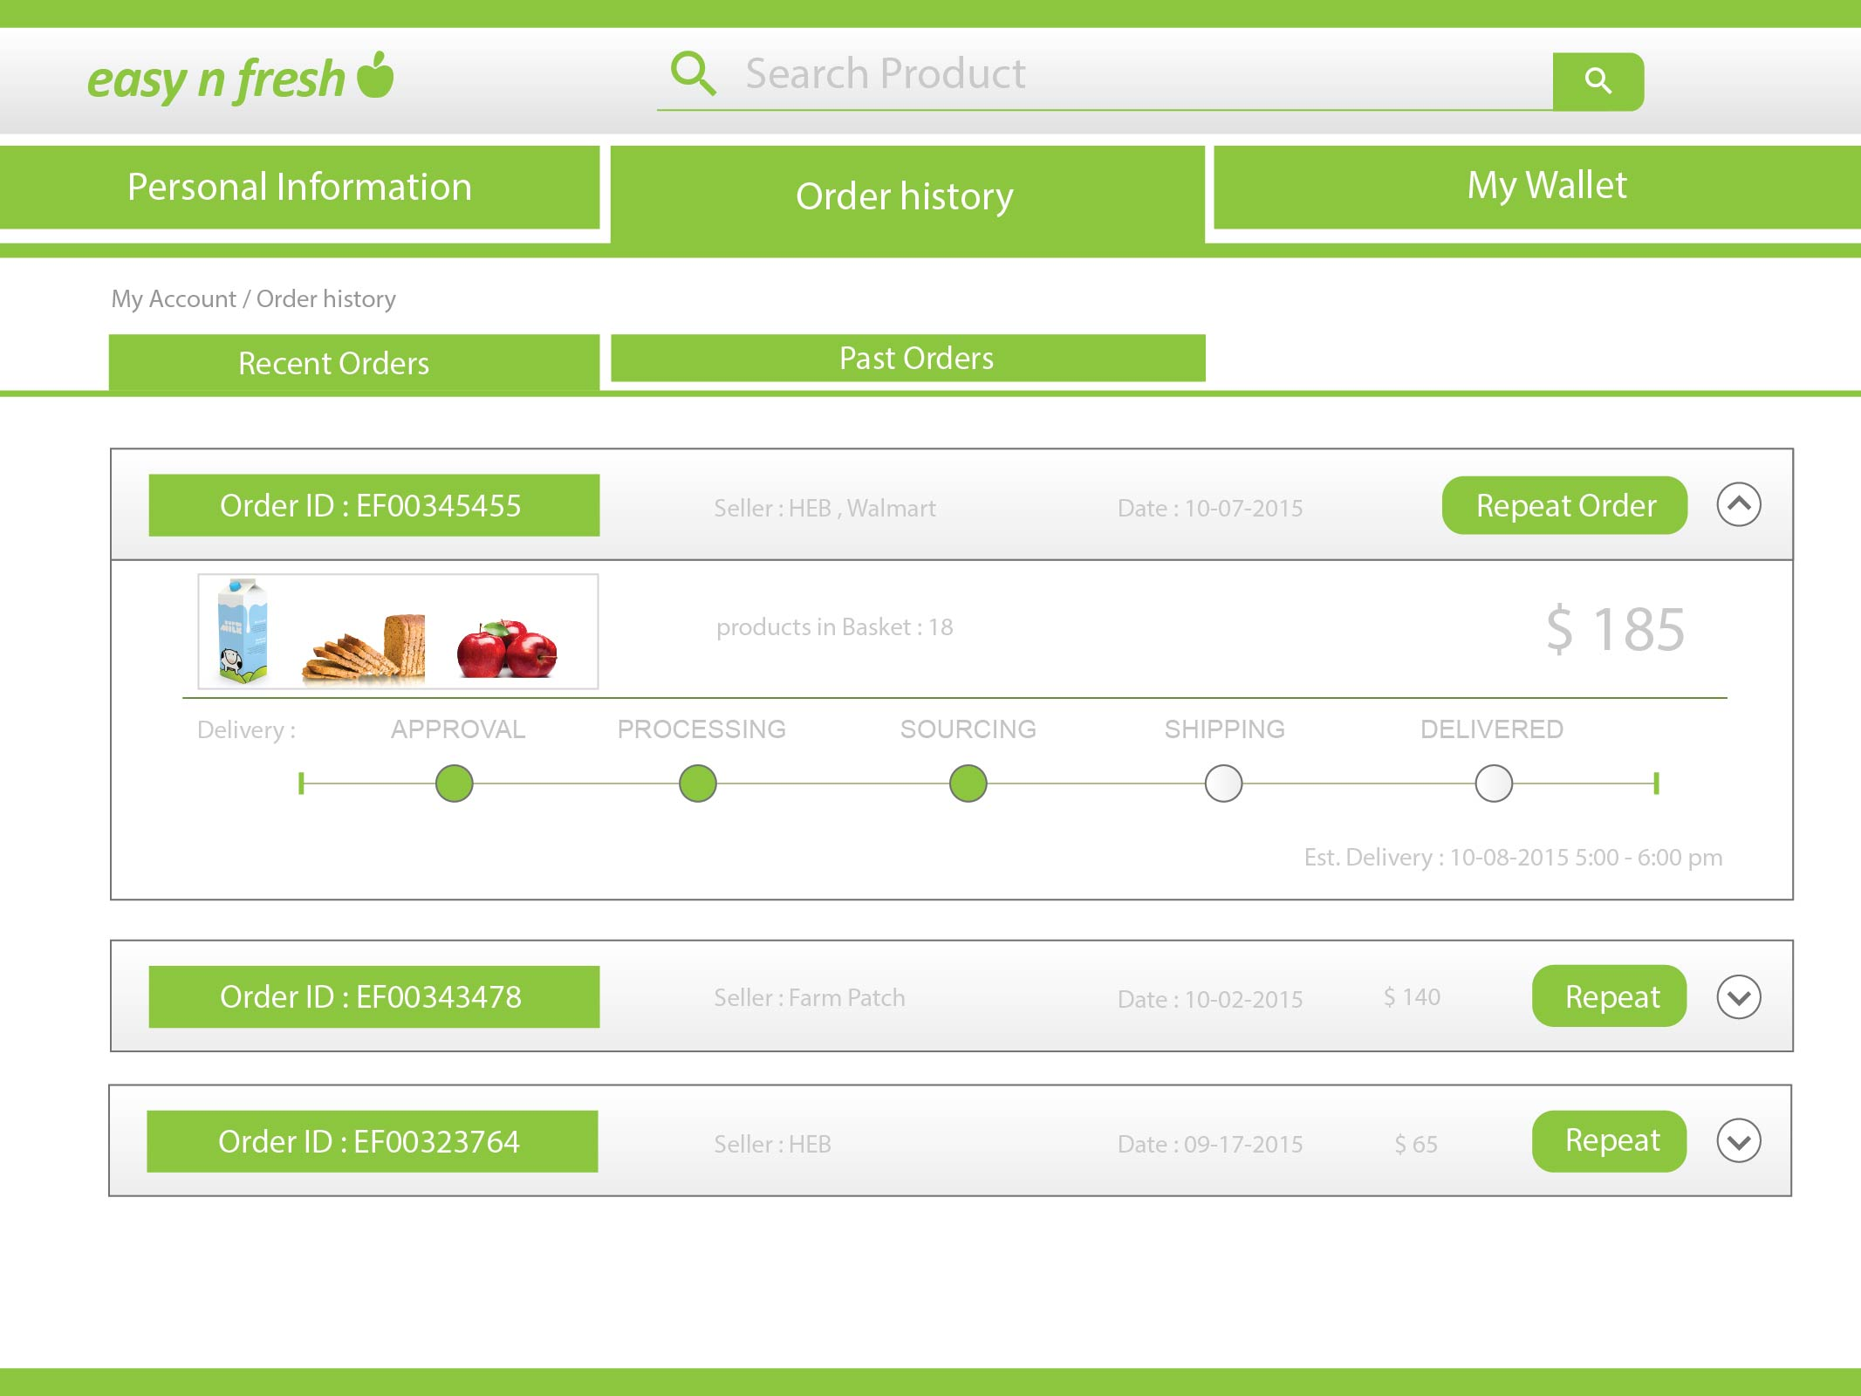

**Fig. 25 Screenshot 4 of ENF system**

1. **Add item to cart**

Customer can view the product and choose the retailer from which he wants to purchase the item. Here, he can add the product to the cart and proceed to checkout.

**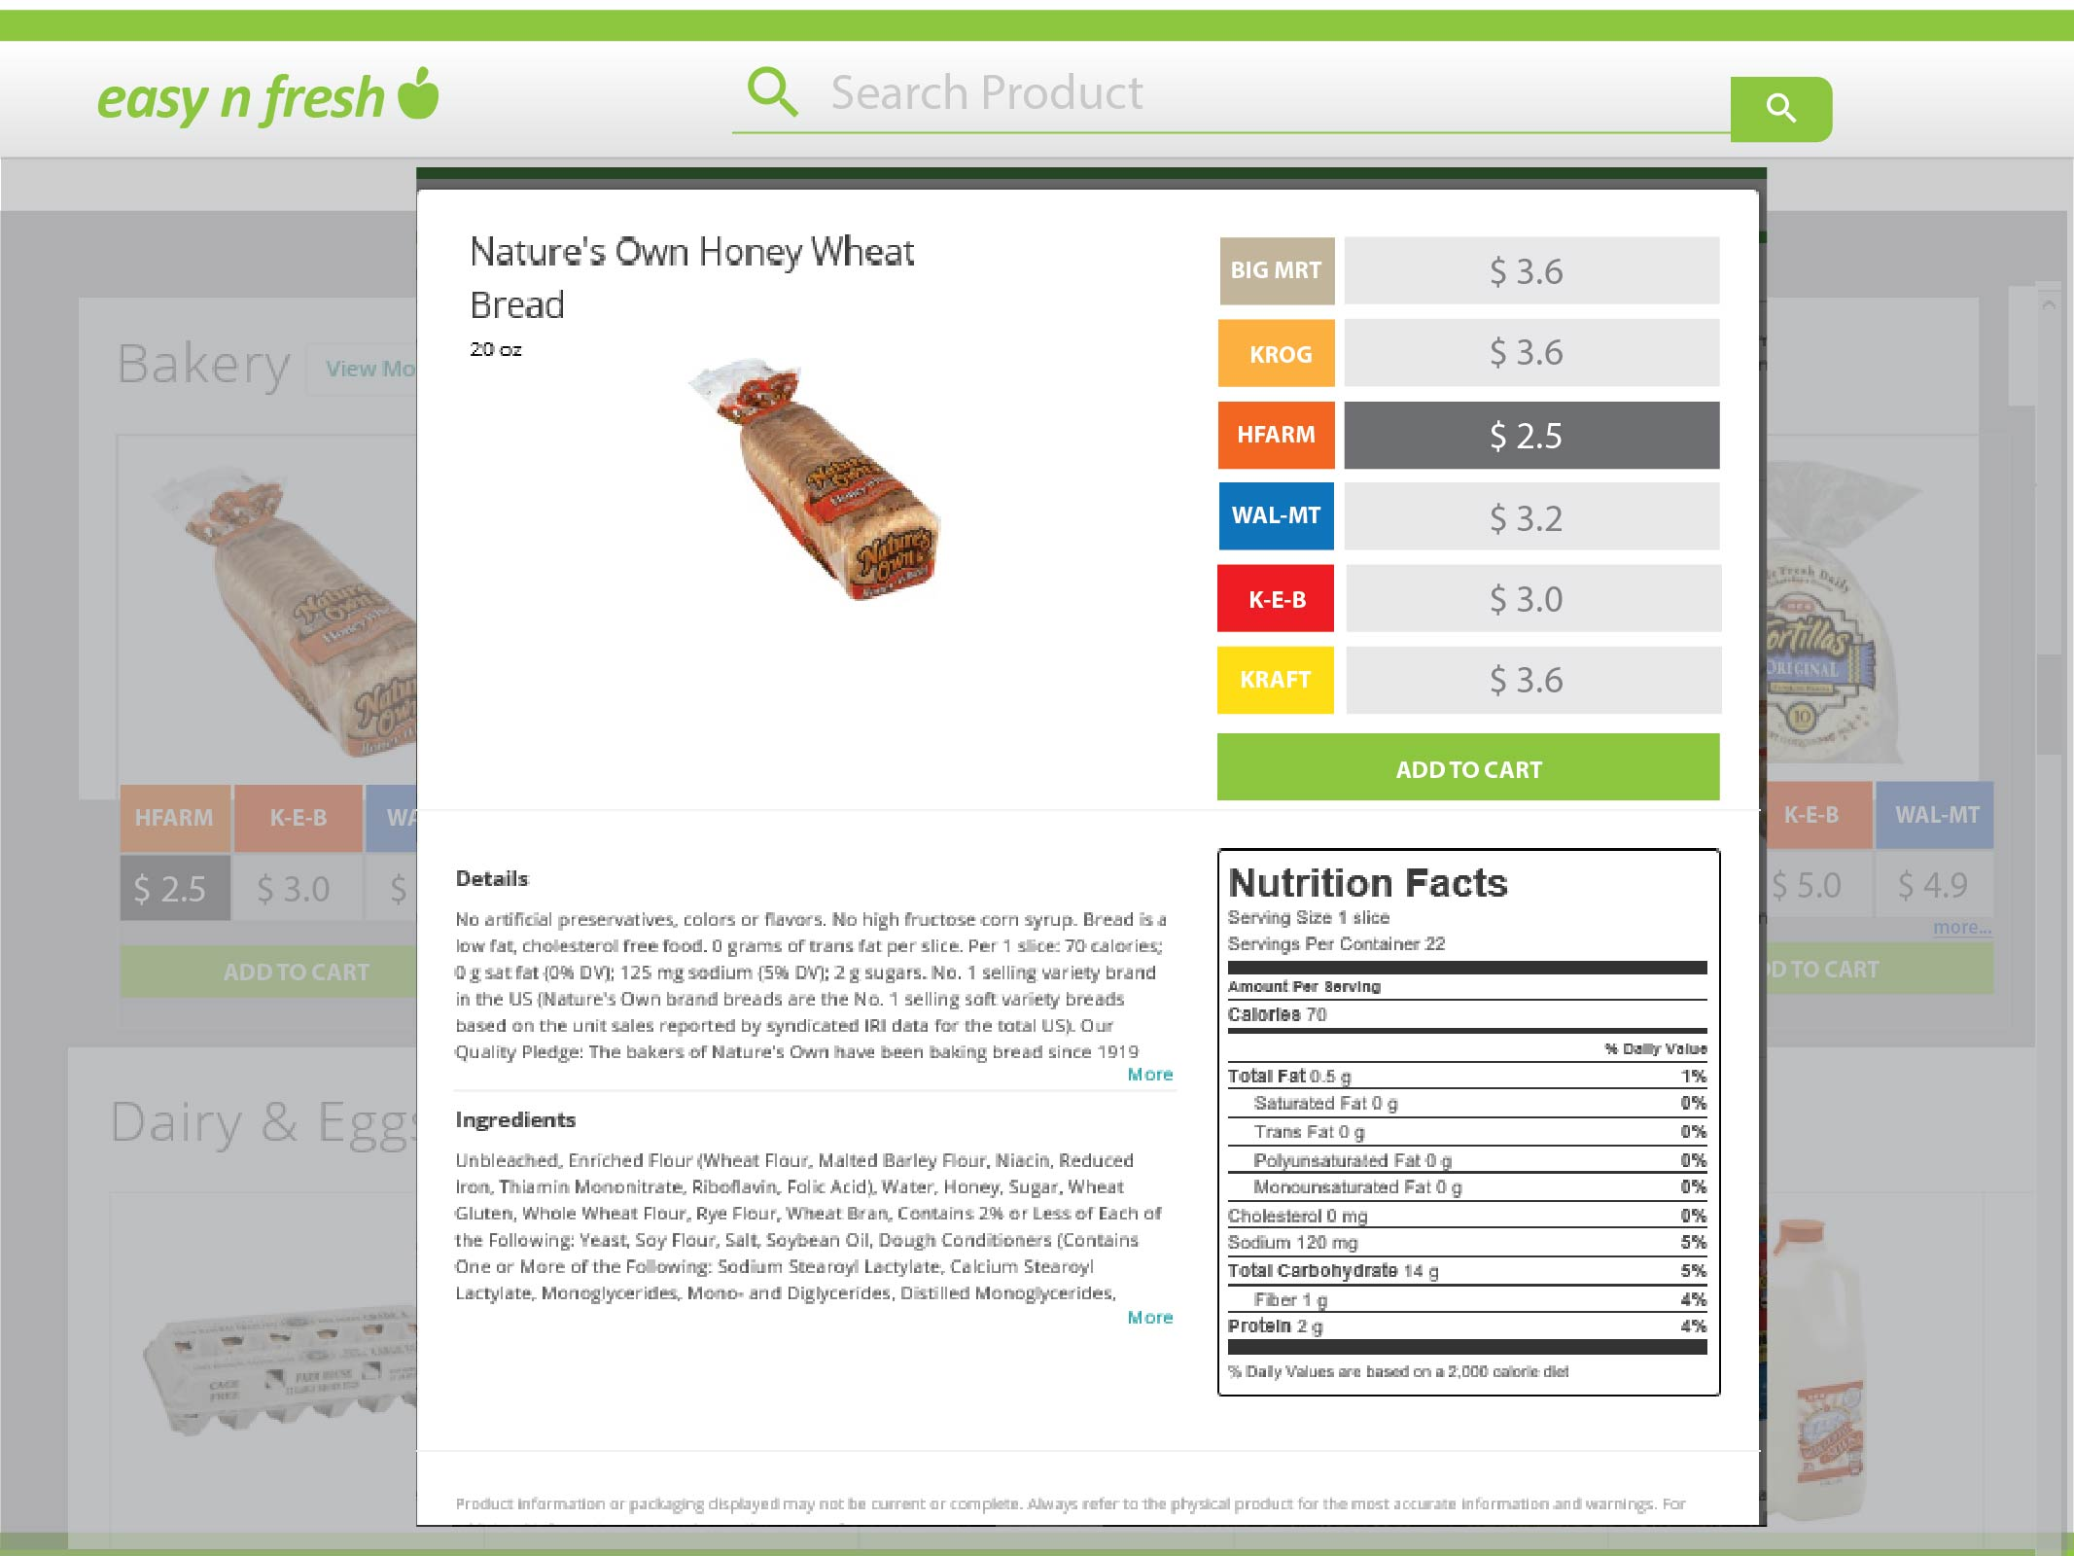**

**Fig. 26 Screenshot 5 of ENF system**

1. **Checkout**

In the checkout, the customer chooses the delivery option he wants. It could be either delivery or pickup form a warehouse.

**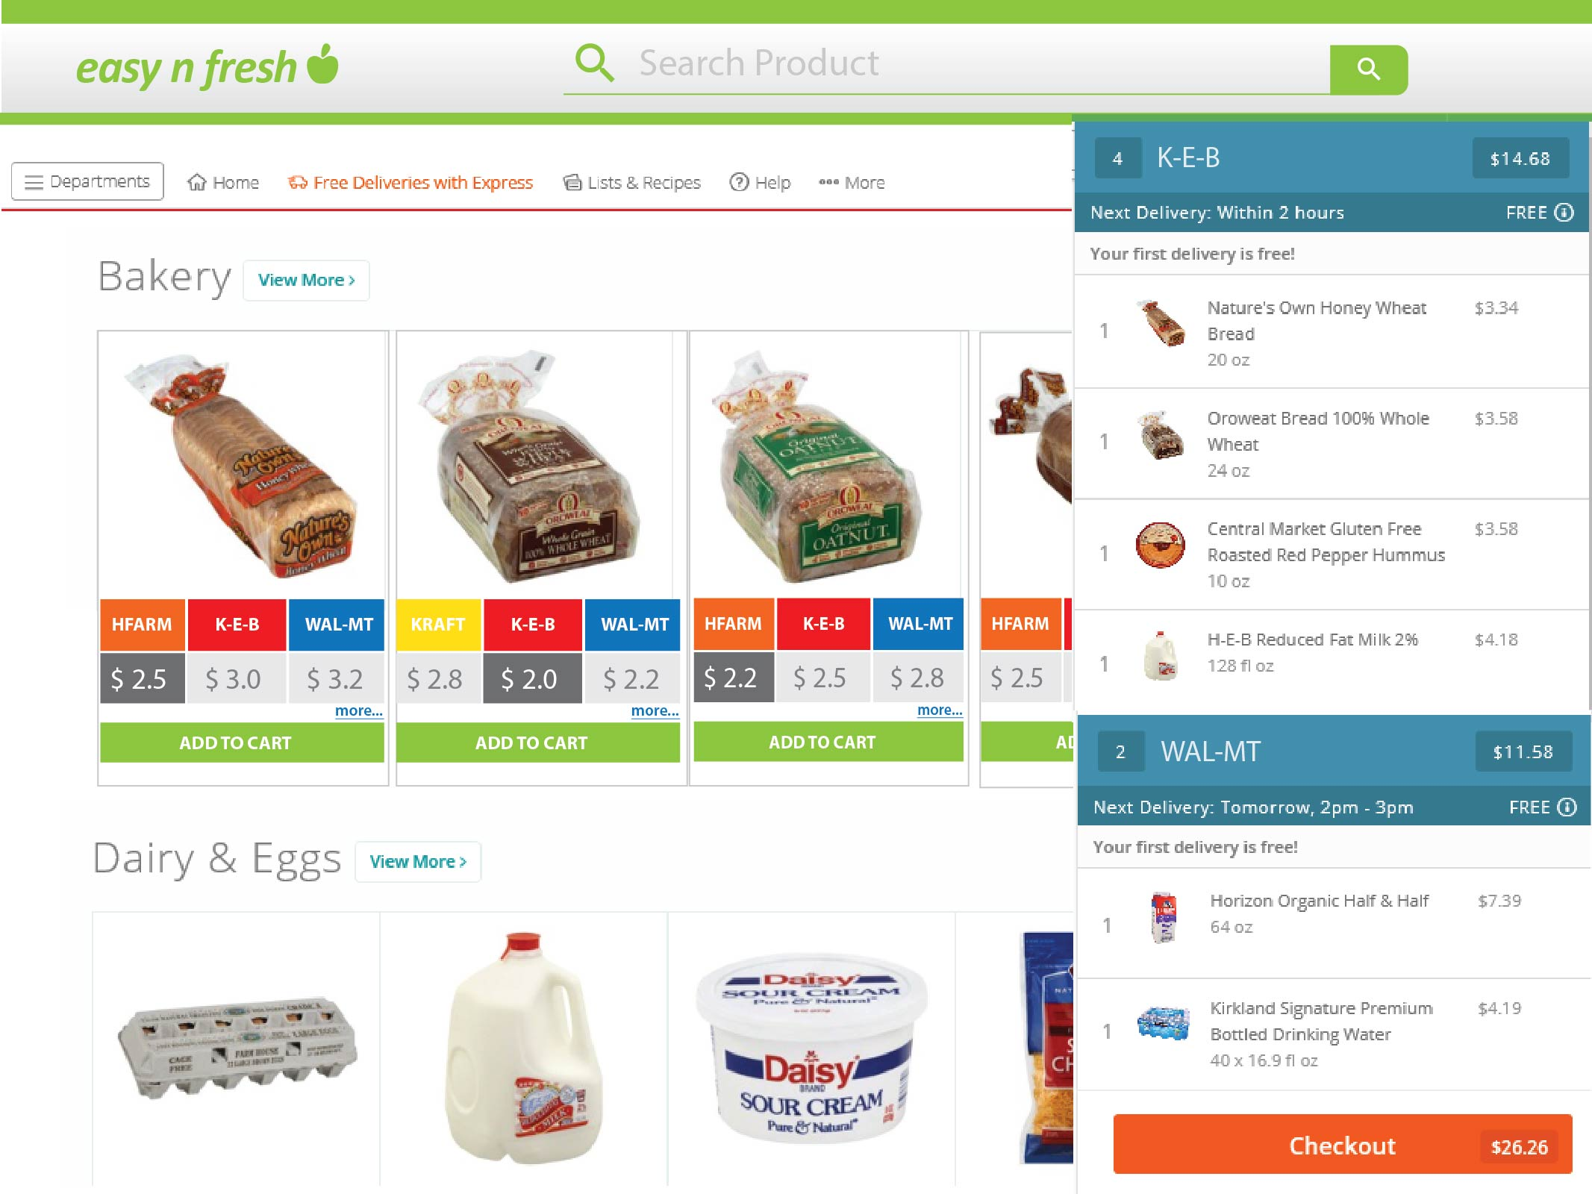**

**Fig. 27 Screenshot 6 of ENF system**

1. **Wallet and Payment**

In this page the customer can see the money available in wallet and choose a payment option. On clicking on payment, the system will proceed to a third party payment gateway system.

**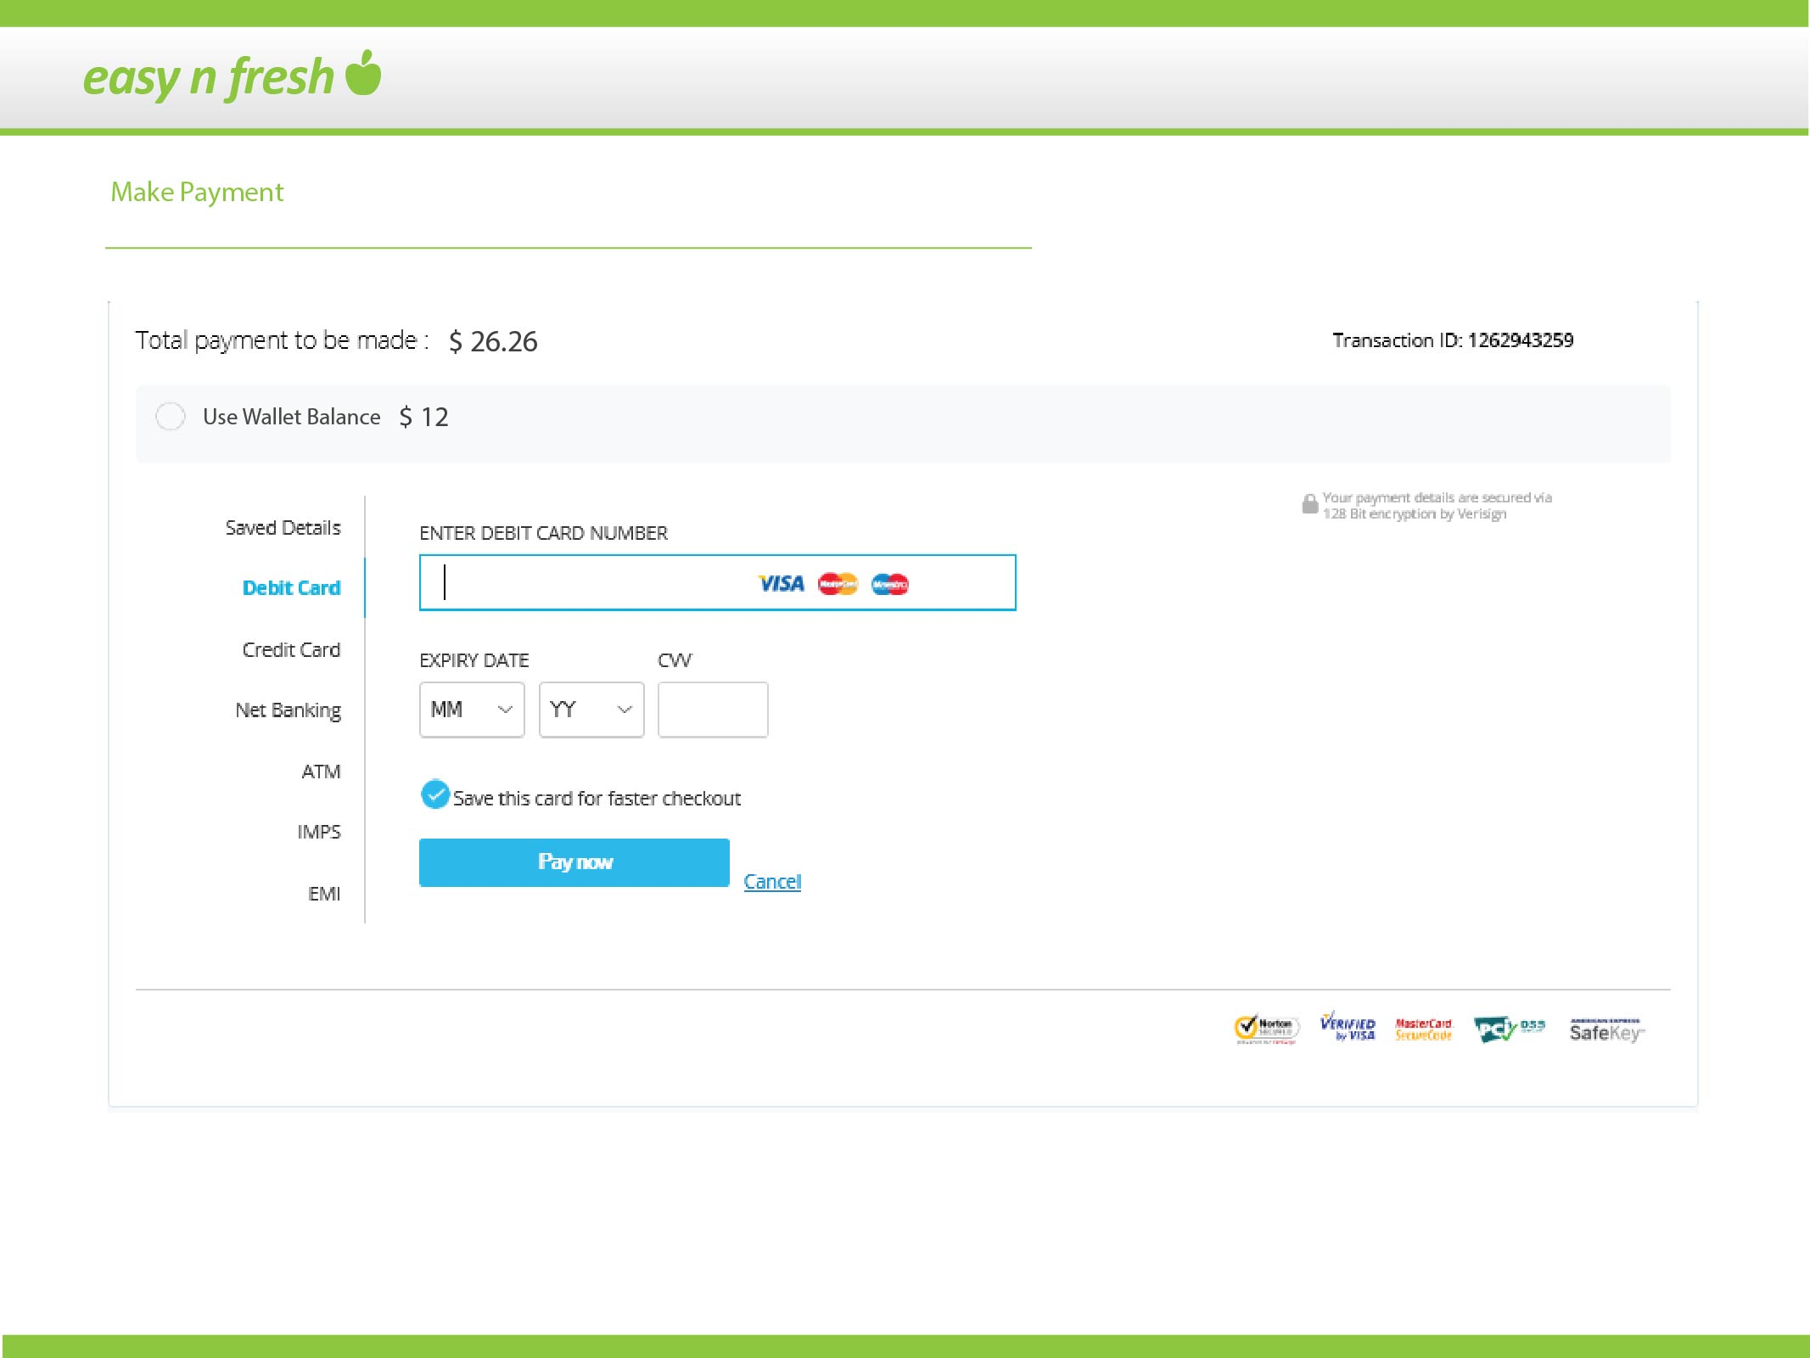**

**Fig. 28 Screenshot 7 of ENF system**

**8 References**

1. **Software Engineering by Ian Somerville**
2. [**www.software-engin.com**](http://www.software-engin.com)